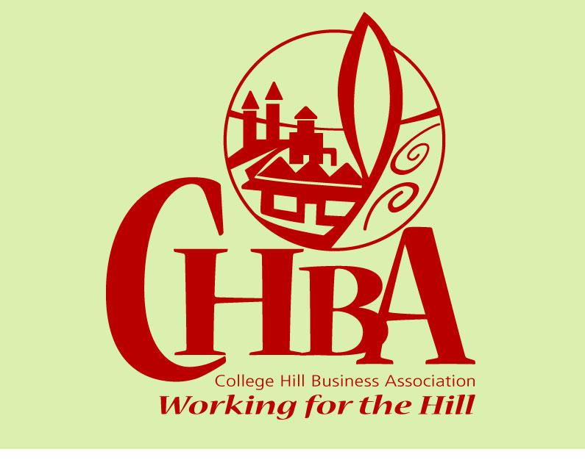
College Hill Business Association

5836 Hamilton Avenue
Cincinnati, OH 45224
513-681-5648

MEMBERSHIP INVITATION & APPLICATION

Your participation in the College Hill Business Association is a very important step to take for your business. Many improvements and new establishments are coming to the College Hill community; be a part of the change!

- CHBA is a resource for networking and help with your business strategies..
- CHBA works cooperatively to host events that help grow our businesses, such as College Hill neighborhood t-shirts, Small Business Saturday and our holiday open houses.
- CHBA funds Hamilton Avenue streetscape plantings, holiday decorations and the CHBA website.

Benefits of membership include: your business info and logo featured on the CHBA website, representation for your business at citywide and local decision making forums and meetings, features in the College Hill e-newsletter, and more.

Monthly meetings are held at 8 a.m. on the first Tuesday of the month, at Bacalls Cafe, 6118 Hamilton Avenue. Annual dues are $50. Pay by check or online through the website.

Questions? Call Leah Marie Kirsch, 513-314-1984
We look forward to seeing you soon.
- - - - - - - - - - - - - - - - - - - - - - - - - - - - - - - - - - - - - - - - - - - - - - - - - - - - - - - - - - - - - - - -

BUSINESS NAME: _____________________________________________________

CONTACT PERSON: ___________________________________________________

ADDRESS: ____________________________________________________________

_____________________@_____________ ________________________
E-MAIL PHONE

Please provide below a brief description of your business as you want it to appear on the CHBA website. __________________________________________________________________________________________________________________________________________________________________________________________________________________

You may email the description & attach a jpeg or PNG image of your logo to: aaron@flemcodesigns.com

PLEASE SEND $50 Dues TO: CHBA, 5836 HAMILTON AVENUE, CINCINNATI, OH 45224
MAKE CHECKS PAYABLE TO CHBA
Office only:_________ _________
Check # Date Rec’d
Rev,TAO2.18

